Practical No. 5
Exam Seat No: 22510044
Name : Ritesh Ramchandra Patil
Batch : B8

Title of practical: Implementation of OpenMP programs.
Implement following Programs using OpenMP with C:

Implementation of Matrix-Matrix Multiplication.

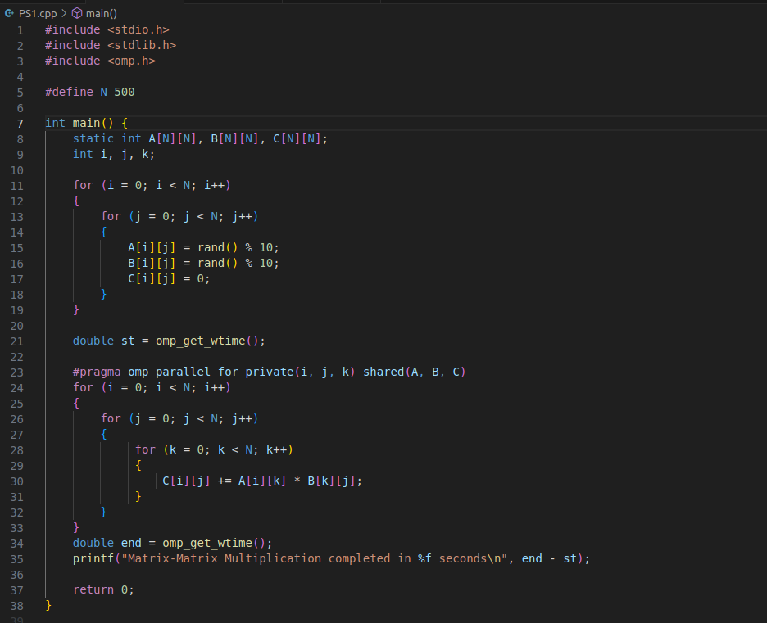

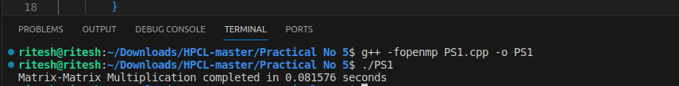

Implementation of Matrix-scalar Multiplication.

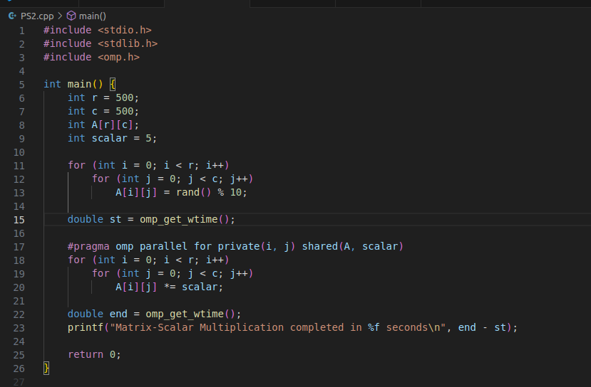

Implementation of Matrix-Vector Multiplication.

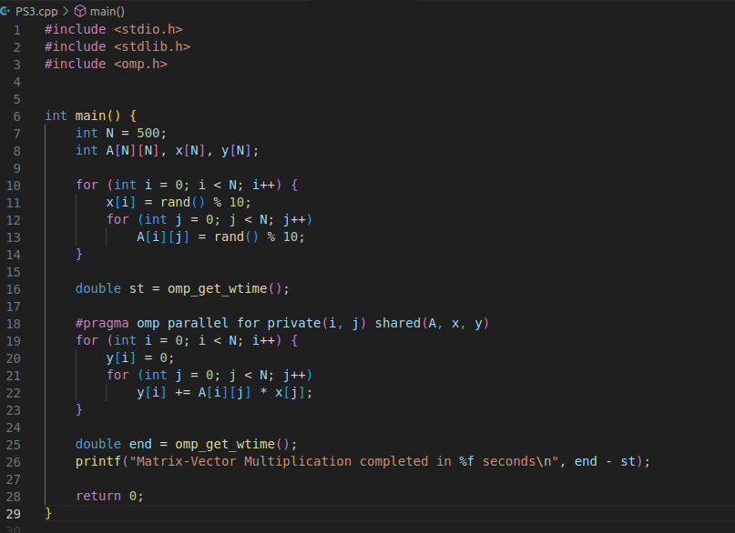

Implementation of Prefix sum

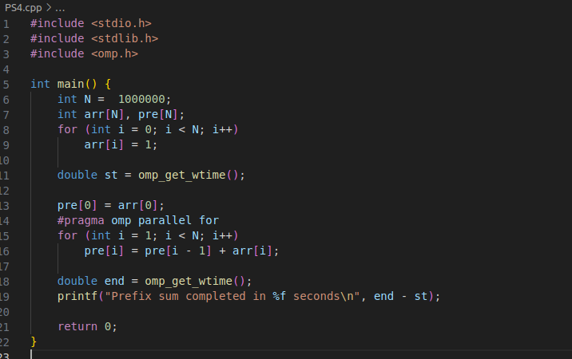

Information

The practical focuses on implementing parallel programming in C using OpenMP, an API that supports multi-platform shared-memory multiprocessing programming.
The programs to be implemented are:
- Matrix–Matrix Multiplication – computing the product of two matrices in parallel.
- Matrix–Scalar Multiplication – multiplying each matrix element by a constant in parallel.
- Matrix–Vector Multiplication – multiplying a matrix with a vector in parallel.
- Prefix Sum – computing cumulative sums of an array using OpenMP.

Why OpenMP?
- OpenMP provides simple compiler directives (e.g., #pragma omp parallel for) to parallelize loops.
- It allows multi-threaded execution, improving performance on multi-core CPUs.
- Minimal code changes are needed to parallelize an existing sequential program.

Key Concepts Used:
- Parallel for loops (#pragma omp parallel for) to distribute iterations across threads.
- Private and shared variables to control data sharing among threads.
- Synchronization in cases where dependencies exist (prefix sum).
- Performance measurement using omp_get_wtime().

Analysis
- Matrix–Matrix Multiplication:
  - High computational complexity: O(N³).
  - Perfectly parallelizable because each C[i][j] can be computed independently.
  - OpenMP divides row and column computations among threads, reducing runtime significantly.
- Matrix–Scalar Multiplication:
  - Complexity: O(N²) for an N×N matrix.
  - Each element is updated independently — no synchronization needed.
  - Parallelization yields almost linear speedup.
- Matrix–Vector Multiplication:
  - Complexity: O(N²) for N×N matrix.
  - Each output vector element is computed independently, allowing efficient parallelization.
  - Speedup is good but less than matrix-matrix multiplication due to fewer operations per thread.
- Prefix Sum:
  - Naive version is loop-carried dependent — current element depends on previous.
  - Full parallelization requires specialized algorithms like Blelloch Scan.
  - In OpenMP, partial parallelism is possible but requires careful synchronization.
  - Demonstrates limitations of parallelism for dependent tasks.

Performance Trend (Expected):
- Matrix–Matrix multiplication → highest speedup due to heavy computation.
- Matrix–Scalar multiplication → high speedup, but fewer operations.
- Matrix–Vector multiplication → moderate speedup.
- Prefix sum → minimal speedup (or even slowdown) unless using advanced parallel algorithms.

Github Link:

